**Assignment**

**Submitted by: Mohammad Faruk, Southtech Limited**

**Title: Running a static HTML file from docker via nginx.**

Step 1: Make a directory **nginx-test**

Step 2: Make another directory **web** inside **nginx-test**.

Step 3: create an **index.html** file inside web folder and write hello-world html codes in index.html.

Step 4: Write the **dockerfile**

FROM ubuntu

RUN apt update

RUN apt install nginx -y

# Remove the default Nginx configuration file

RUN rm -v /etc/nginx/nginx.conf

# Copy a configuration file from the current directory

ADD nginx.conf /etc/nginx/

ADD web /usr/share/nginx/html/

ADD web /var/www/html/

# Append "daemon off;" to the beginning of the configuration

RUN echo "daemon off;" >> /etc/nginx/nginx.conf

# Expose ports

EXPOSE 90

# Set the default command to execute

# when creating a new container

CMD service nginx start

Step 5: Create **nginx.config** file

worker_processes 1;

events { worker_connections 1024; }

http {

include mime.types;

sendfile on;

server {

root /usr/share/nginx/html/;

index index.html;

server_name localhost;

listen 90;

}

}

Step 6: **Build** the docker file as image name html-test

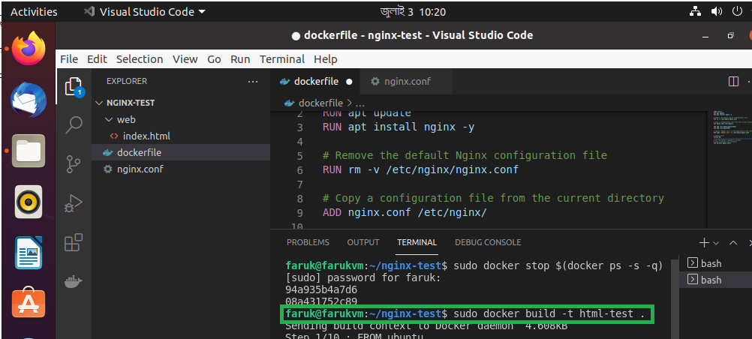

Step 7: **Run** html-test docker image

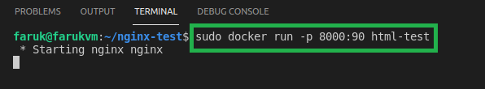

Step 8: Check the **result**

